NETWORK OF AFRICAN NATIONAL HUMAN RIGHTS INSTITUTIONS
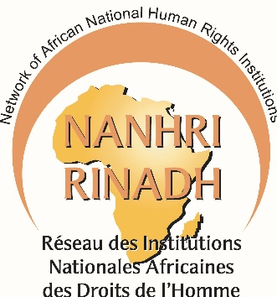

55th Session- Statement to the Human Rights Council
Item 3

8 March, 2024

Dear Mr. President, Distinguished Delegates,
NANHRI welcomes the HRC Resolution 52/11 and has the honor to submit as follows.
The state of social security rights in Africa is dire. Effective social protection coverage is the lowest in the world, averaging at 17.4% of the total population, far below the ILO target of 40% and the world average of 47%.
Conscious of the impact of social security on human rights, African NHRIs emphasized the need for a human rights-based approach and involvement of HRDs in the elaboration of COVID-19 national response strategies. Additionally, NANHRI published a report on advancing social security rights.
NANHRI calls to;
- Ratify the African Protocol on the Rights of Citizens to Social Protection and Social Security;
- Review policies and legislative frameworks and align them with universal human rights standards on the right to social protection and social security;
- Monitor, investigate and report on the right to social protection and social security and provide redress for established human rights violations thereto, while emphasizing marginalized and disadvantaged groups including migrants, persons with disabilities, paying attention to intersecting forms of marginalization, such as elderly migrants;
- Enhance synergy between National Statistical Offices, National Social Protection Agencies, research institutes and UN agencies to ensure a human rights-based approach to data collection including SDG data collection;
Thank you.
Adv. Joseph Whittal, NANHRI Chairperson

